**Name:-** Gaurang A Raorane **Div:-** D15A

**Roll No:-** 49 **Batch:-** C

**LAB 3**

**Aim:- To Perform various GIT operations on local and Remote repositories using GIT Cheat-Sheet**

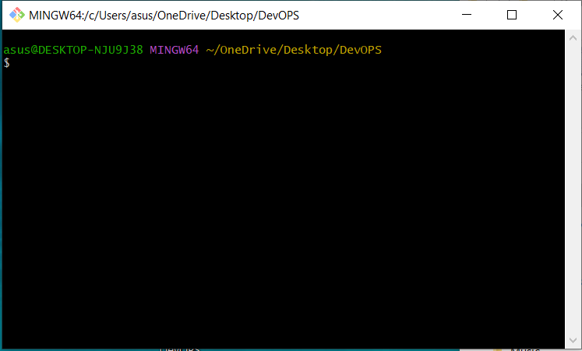

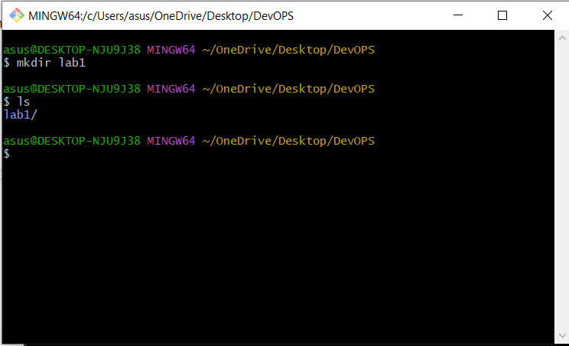

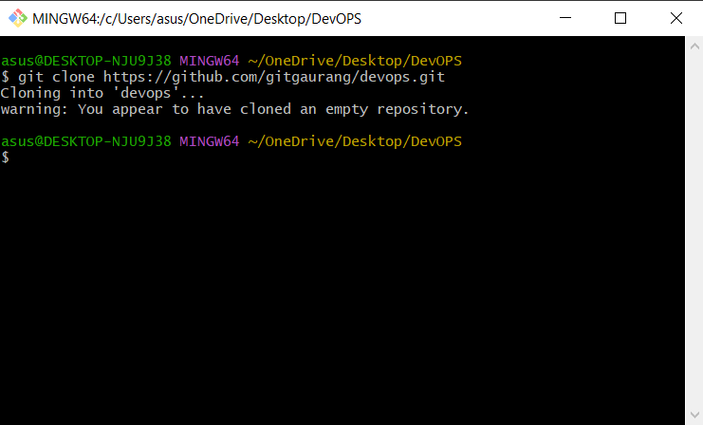

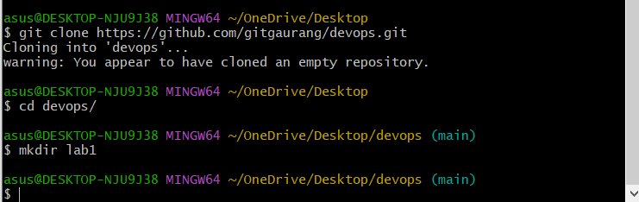

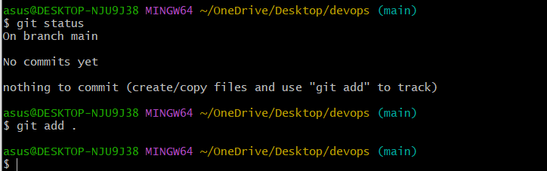

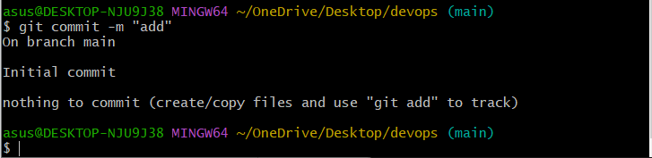

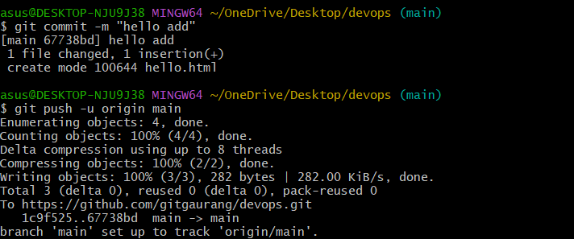

**Conclusion:-**

Performed various got operations on remote and local repository.

1. Faced errors while pushing the code to remote repository.
2. Faced errors while using git pull due to incorrect command.